Lesson Plan
“ATV Safety in Motion”
Stability of ATV and UTV

Instructor:
Course:
Unit:
Lesson Title:
Estimated Time:
Objective(s) of Lesson: What you want your students to KNOW and/or be able to DO
Objectives of Seminar:
- Properly inspect ATV for safe operation
- Recognize and avoid hazardous situations involving ATVs
- Explain center of gravity, centripetal force and angular momentum
- Discuss reaction time
- Identify safety recommendations in matching machine size and tasks with the age and ability of the operator.
- Perform a SAE risk assessment for ATV operations

Materials, Supplies, Equipment, References, and Other Resources:
- https://extension.psu.edu/navigating-the-say-national-clearinghouse
- https://extension.psu.edu/national-safe-tractor-and-machinery-operation-program
- https://www.cultivatesafety.org//wp-content/uploads/2017/09/2017-09-ATV-Riding-is-not-childs-play.pdf
- https://haynes.com/en-us/atv-manuals
- https://atvsafety.org/free-booklets/
- https://atvsafety.org/atv-ridercourse/
- https://atvsafety.org/atv-ecourse/
Situation: (WHO are you teaching)
Agricultural Education Teachers interested in updating students on SAE safety and agricultural mechanics safety. Motivation includes incorporating academic content (physics and math) with hands-on activities.

Interest Approach (Motivation):
Interest Approach

ATV’s accounted for 2,090 injuries and 321 fatalities related to ATVs occurred between 2003 and 2011 – with 3 out of 5 workplace deaths occurring in agriculture. Loss of control and rollovers account for may incidents involving ATV use in agricultural operations.

Before we begin today, we’d like you to think about some answers to the following question.

How do we stay focused on operating ATVs or UTVs safely?

Next, we have a short video for you.

Show video and facilitate discussion questions for a total of five minutes.
http://natgeotv.com.au/videos/brain-games/jason-silva-on-focus-6DB34C36.aspx

Interest Approach Questions for Discussion:
How stretched are you with processing all the variables involved in operating an ATV?
How do we ride ATVs and UTVs safely?
When does a person run on autopilot?
Can you do this your eyes close?
What do we really see?

Communicate Objectives, Define Problem or Decision to be Made, or Identify Questions to Investigate:
Today we will more about opportunities for injury prevention and control by proper planning of SAE supervision specific to operating ATVs and UTVs.

For our purposes, injuries are a result of an uncontrolled interaction between a host, an agent, and the environment. This seminar will be focused on safe tractor operations and assessing risks. The goal will be to accomplish as synergy in safety utilizing academic content standards and hands-on activities.

Instructor Directions / Materials  HOW you will teach | Content Outline, Instructional Procedures, and/or Key Questions  WHAT you will teach
NSTOMP Task Sheet 1 – Sections 1.2; 1.2.1; 1.2.2 | - Introduction with an overview of the agenda and purpose of research. Outline the rotations then ask for questions on logistics and rotation. Then have the teachers take pretest.  - Include hands-on activities.  - Show the website http://www.youthrules.gov/know-the-limits/agriculture/index.htm discuss what is allowable.  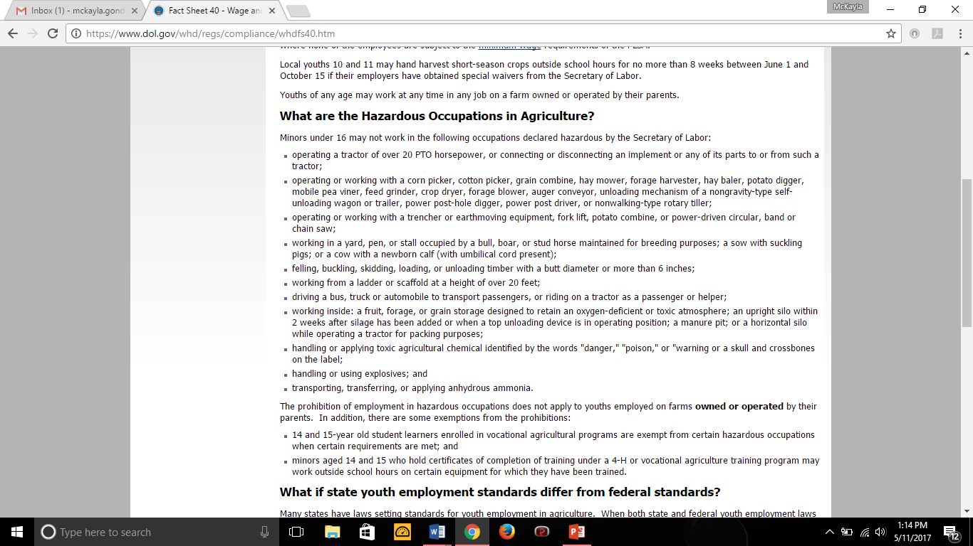
Walk-Around Job sheet using SAE Risk Assessment and NSTOMP Checklist | *Large Group Session*  Show video on hazards of ATV use.  Accomplishign Objectives 1 & 6  Follow-up the videos up with hands-on activity.  Hands-on Activity  Option 1: Have a ATV on site for walk-around and inspect using SAE sheets and checklist from NSTMOP.  Option 2: Take students on a field trip to a dealer and inspect using SAE sheets and checklist from NSTMOP.  Option 3: Use digital pictures on PowerPoint to have students inspect using SAE sheets and checklist from NSTMOP.  In this rotation, you will be inspecting ATVs for safe operations, recognizing and avoiding hazardous situations, and performing an SAE Risk assessment.  The top items to inspect on every ATV are….  NSTOMP Task Sheet 4.6, 4.6.1, & 6.2
Mini Tilt Table lesson  Angle and stability worksheet  Model ATV/UTV | *Small Group Break Out Session*  Rotation one  Accomplishing Objective 3:  Hand on Activity  Angles and Stability ATV/UTV  Teachers may complete the pre-fabrication of parts for demonstration during seminar.  These files are for teachers to use with students.  In this rotation, you will be performing the lesson plan on Angles and Stability.  Step 1:  Step 2  Step 3:  Step 4:  Step 5: Tear down and leave for next rotation.
Tilt Table Job Sheet | *Small Group Break Out Session*  Rotation Two  Accomplishing Objective 3 & 5:  - Explain center of gravity, centripetal force and angular momentum  - Discuss reaction time  Show videos from YouTube  https://phet.colorado.edu/en/simulation/forces-and-motion-basics  https://youtu.be/9s1IRJbL2Co Centripetal force  https://youtu.be/zHpAifN_2Sw Centripetal Force II  Complete hands-on activity  Hands-On Activity  - Tilt Table Demonstration (center of gravity)  Students can then build demonstration units as part of hands-on skill development and demonstrate to the class their safety instruction function. Teachers and students could then use the kits to provide community outreach.  Hands-on Activity  Reaction time demonstration
ATV and UTV Obstacle Course Design | *Small Group Break Out Session*  Rotation Three  Accomplishing Objectives 2-4  Show videos from YouTube  Hands-on Activity  - Obstacle course Design lesson plan
Large Group
Accomplishing Objective 6:

- Research recommendations for matching machine size to operators

https://extension.psu.edu/atvs-and-youth-matching-children-and-vehicles ,
https://atvsafety.org/one-size-doesnt-fit-all/
https://www.cultivatesafety.org/safety-guideline/?guideline=21&interact=false
NSTOMP Task Sheet 2 – sections 2.1-2.4, 6.2 | Large Group  Accomplishing Objective 7:  - Identify safety recommendations in matching size and tasks with the age and ability of the operator.  http://www.youthrules.gov/index.htm  End session with a  review of youthrules.gov so that SAE multiple types can be  addressed.  Guest Speaker Option:  Have local law enforcement prepare a FAQ on rules of the road and ATV use.  Review ATV Vehicle Hazards during Farm Work  https://www.osha.gov/Publications/OSHA3758.pdf
Application: | Throughout the Workshop
Closure/Summary: | Closing summary and research recruitment data collection
Evaluation: | Post-test

